Lauren Jablonski

**Assignment 6B Reflection**

This assignment was challenging but interesting. I learned a lot about how functionality

applies to programming, and I’m starting to recognize different patterns of computer behavior. That said, I did run into many bugs, and the largest challenge for me was figuring out how different pieces of code worked together.

I struggled with understanding storage during our labs and as a result, I spent many days with an “almost” shopping cart. I had document.GetElementById statements along with event listeners, and even a “for loop” for quite a few days before I could get anything to work together on my actual website. I watched YouTube Tutorials online for help with the steps and looked up examples of other Javascript functions on the websites listed in my source section below for reference. These were helpful in getting me to build the “pieces,” but it wasn’t until speaking with my classmates and TA, Sai, that I realized I needed an array and that I hadn’t called the functions I’d created.

Even with that knowledge, I struggled to retrieve my objects from local storage where they were successfully printing via console.log until I got tutoring help through WyzAnt.com. My tutor Nathan walked me through my code step-by-step and explained that I had things in the wrong order and helped me to understand the object/item creation process that I hadn’t grasped in the original Zoo Animal Lab.

I ran into many bugs throughout the assignment, such as “cart.push” functions not being recognized, hard to find typos breaking my code, retrieving my stored items from local storage that had been stuck in cyber space, and then deleting them from local storage after the fact. Nathan introduced me to Visual Studio Code to help combat the small errors like typos that I wasn’t finding while using Sublime. He also helped me work through the errors by looking them up in the Console on Chrome and showing me how to correctly use console.log when debugging.

It’s definitely a process, but I’m starting to get better, and improvement is a good feeling.

**5 Learned Concepts:**

1. **Json.parse:** I learned the importance of transforming data from a “string” into an object using Json in order to be able to manipulate it:

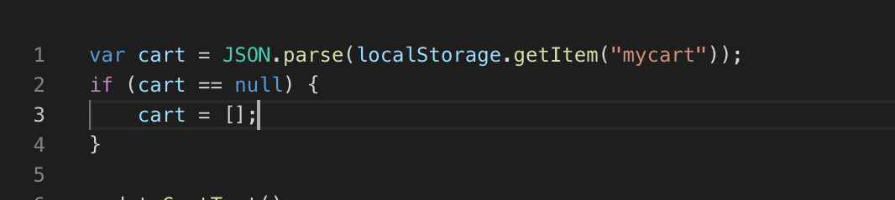

1. **Creating Objects:** I learned how to create objects (through the Zoo animals lab and with the help of my tutor) in order to be able to add items to an array for local storage:

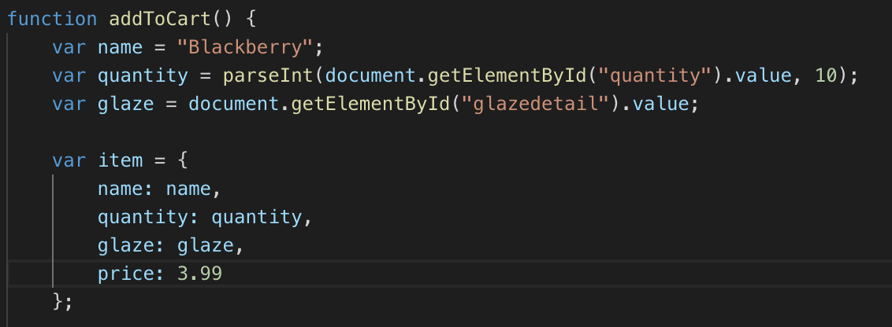

1. **Local Storage:** I learned the difference between local storage and session storage and when to use them. Session storage will only last as long as the web session does and will not save the information after the fact.

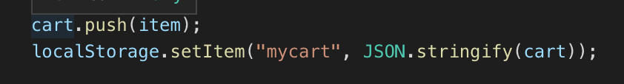

1. **Get Elements by Id:** I learned how to “get” elements from HTML that I would like to add functionality to in Javascript in order to create my shopping cart:

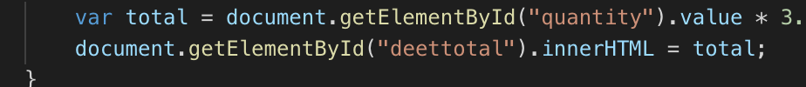

1. **Event Listeners:** I also learned how to use even listeners in order to tell Javascript when to perform a certain function. So far I think of GetElementById as the “where” something should happen, “addEventListener” (such as click, change, onload, etc…) as the “when” something should happen, and Javascript functions as the “what” should happen to my code.

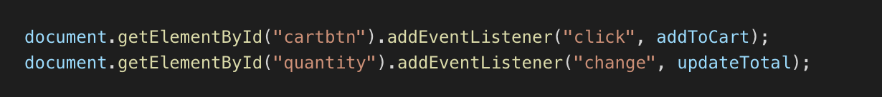

**Sources Referenced:**

I worked through debugging issues with the help of my classmates, Lauren Whittingham, Megan Parisi, and Aaron Bishop.

I worked through larger structural and function-related issues with the help of my TA Sai, and my two coding tutors through WyzAnt.com, Nathan and Steve (approved by Jason).

Stack Overflow: <https://stackoverflow.com/questions/16293977/creating-a-shopping-cart-using-only-html-javascript>

Learn Web Code YouTube Channel: Javascript in Half an Hour (Without JQuery) <https://www.youtube.com/watch?v=zPHerhks2Vg&t=1683s>

Web Dev Simplified YouTube Channel: Javascript Shopping Cart Tutorial for Beginners <https://www.youtube.com/watch?v=YeFzkC2awTM>

Codyhouse.co: <https://codyhouse.co/gem/add-to-cart-interaction>

W3Schools.com: various searches including Json.parse <https://www.w3schools.com/js/js_json_parse.asp>

Traversy Media YouTube Channel: Javascript for Absolute Beginners <https://www.youtube.com/watch?v=vEROU2XtPR8>